Big Data Analytics

HTU
MOHAMMAD EMAD JABER 22110036

Contents
Executive Summary 4
Activity 1 Big Data Concepts and Data-Driven Decision 5
1. Introduction 5
2. Fundamental concepts of Big Data 5
2.1 What is Big Data? 5
2.2 3Vs of Big Data 5
2.3 7Vs 5
2.4 Why Big Data matters for TransLogix 6
2.5 Value for end users and the organization 6
3. Stages of the Data-Driven Decision-Making (DDDM) process 7
4. Advantages and challenges of using complex datasets 8
4.1 Advantages 8
4.2 Challenges 9
5. Prediction (3–5 years): Impact of using complex datasets on TransLogix 9
5.1 Positive impacts 9
5.2 Negative/unintended impacts 10
6. Conclusion 11
Activity 2 Statistical and Graphical Tools for Big Data 12
1. Introduction 12
2. Statistical and graphical tools/techniques used in industry for big data manipulation and visualization 12
2.1 Statistical tools and techniques 12
2.2 Graphical and visualization tools/techniques 13
2.3 Data manipulation tools used before statistics and visuals 13
3. Assessment: How suitable are industry-leading tools for TransLogix? 14
4. Justification: Tools and approaches chosen for my practical work 16
5. Planned data preparation, transformation, and automation steps 16
6. Evaluation of impact on decision making 17
7. Conclusion 18
Activity 3 Practical Demonstration: Big Data Manipulation and Visualization 18
1. Introduction 18
2. Data preparation, manipulation, and automation 18
2.1 Cleaning and preprocessing 18
Removal of irrelevant variables (preprocessing justification): 19
2.2 Derived features created 19
2.3 Automation 19
3. Analytical manipulation operations (grouping, aggregation, sorting, filtering) 19
3.1 filtering 19
3.2 Grouping, aggregation, and sorting 20
4. Visualizations + interpretation and operational meaning 20
4.1 Average Delay by Month (Line Chart) 20
4.2 On-time vs Late Shipments (Bar Chart) 21
4.3 Average Delay by Day of Week (Bar Chart) 21
4.4 Average Delay by Departure Hour (Heatmap) 22
4.5 Origin Congestion vs Delay (Scatter Plot) 22
4.6 Top Origin Hubs by Average Delay (Bar Chart) 23
5. Predictive modelling: 3 models to estimate delay_minutes (RMSE + R² comparison) 24
5.1 Models developed 24
5.2 Features used (feature selection) 24
5.3 Model evaluation results 24
5.4 Preferred model and justification 25
6. Recommendations and decision-making impact + evaluation (with limitations) 25
6.1 Operational recommendations 25
6.2 Evaluation of effectiveness (tools + methods) 25
6.3 Limitations, assumptions, and improvements 26
6.4 Code screenshots 26
Activity 4 Professional Roles and Challenges in Big Data Environments 34
1. Introduction 34
2. Roles, day-to-day responsibilities, and key issues 34
2.1 Data Engineer 34
2.2 Data Analyst / Business Intelligence (BI) Analyst 35
2.3 Data Scientist / Machine Learning Engineer 35
2.4 Data Governance / Compliance Officer 35
2.5 DevOps / Cloud Engineer (Big Data Platform Support) 35
3. Strategies to ensure compliance (legal, ethical, data governance) 36
3.1 Data privacy and confidentiality 36
3.2 Access control and role-based permissions 36
3.3 Data quality governance (rules + monitoring) 36
3.4 Ethical use of analytics and avoiding bias 36
3.5 Retention, documentation, and audit trails 36
Assessment of how well strategies work + improvement needs 36
4. Evaluation of impact of key issues in a data-driven culture 37
4.1 Impact of data quality and standardization issues 37
4.2 Impact of security and privacy risks 37
4.3 Impact of bias and unfair decision-making 37
4.4 Impact of complexity and skills gap 37
Reasoned judgement (overall importance for TransLogix) 38
5. Conclusion 38
References 38

Executive Summary
This report analyzes how TransLogix can use big data analytics and data visualization to reduce shipment delays and congestion in distribution hubs. TransLogix collects large amounts of logistics data from GPS tracking, vehicle sensors, warehouse scanners, and fleet management systems. The report explains key big data concepts (3Vs and 7Vs) and shows how the Data-Driven Decision-Making (DDDM) process helps managers turn raw data into insights and actions. It also discusses the benefits and challenges of using complex datasets, including data quality, standardization, bias risks, and the need for clear dashboards.
The practical work uses Python with Apache Spark (PySpark) to clean and prepare the TransLogix dataset, create derived features (delay status, time features, peak-hour flag), and perform aggregation analysis by hub, route, and time. The results are visualized using Python charts and an interactive Power BI dashboard. In addition, three predictive models were developed to estimate delay minutes (Linear Regression, Random Forest, and Gradient-Boosted Trees). The Gradient-Boosted Trees model performed best with the lowest RMSE and highest R², making it the most suitable option for predicting delays and supporting proactive operational decisions. Overall, the report provides evidence-based recommendations to improve hub performance, adjust scheduling during peak periods, and use predictive analytics to reduce delays and improve service reliability.

Activity 1 Big Data Concepts and Data-Driven Decision

1. Introduction
TransLogix Solutions is a logistics company. It delivers goods and manages warehouses and distribution hubs. Every day TransLogix collects a lot of data from GPS tracking, vehicle sensors (telematics), warehouse scanners, delivery schedules, and system logs. The main problem is shipment delays and congestion at hubs. TransLogix wants to use big data and visualization to understand the reasons for delays and improve operations.

2. Fundamental concepts of Big Data

2.1 What is Big Data?
Big Data is data that is too large, too fast, or too complex for normal tools (like Excel) to handle easily. It needs special storage and processing tools.

2.2 3Vs of Big Data
Volume: TransLogix has many records (shipments, GPS points, hub scans, driver events). This becomes millions of rows quickly.
Velocity: GPS and sensors send data every few seconds/minutes, so the system must handle fast incoming data.
Variety: Data comes in different formats, such as:
- tables (delivery time, route, hub)
- sensor readings (speed, fuel, temperature)
- text notes (driver comments)
- traffic/weather data from outside sources
The 3Vs explain why TransLogix data is “big”. Volume is high because there are many deliveries and scanning events. Velocity is high because GPS updates arrive quickly. Variety is high because the company uses different systems that create different data types.

2.3 7Vs
- Volume: huge amount of shipments and tracking events.
- Velocity: real-time updates, needed for quick action.
- Variety: many data types from trucks + warehouses + external sources.
- Veracity: data may have errors (GPS lost signal, wrong scan time, missing values).
- Value: the goal is to use data to reduce delays and cost.
- Variability: data changes depending on season, holidays, rush hours, or road closures.
- Visualization: dashboards and charts make complex data easy for managers to understand.
The 7Vs give more detail about big data. TransLogix must care about veracity because wrong GPS or scan times can mislead decisions. Value is important because the goal is better delivery performance. Visualization is also key because managers need to understand results quickly.

2.4 Why Big Data matters for TransLogix
Big Data analytics helps TransLogix to:
- find which hubs cause most delays
- discover delay patterns (time of day, day of week, route type)
- predict delays before they happen (using historical patterns)
- support fast decisions using dashboards (for managers and planners)
Big data matters for TransLogix because it helps the company understand delays using real evidence. When managers know the main delay locations and times, they can improve planning and reduce congestion. This leads to faster deliveries and better customer satisfaction.

2.5 Value for end users and the organization
Value for end users (managers, planners, hub supervisors):
- They can see delay reasons quickly (not guessing).
- They can compare hubs and routes using charts.
- They can focus on the biggest problems first.
End users like planners and hub managers need clear information to do their job. Big data helps them see where delays happen and what causes them. Dashboards make the data easier to understand. This helps them act faster and solve problems early.
Value for TransLogix (the company):
- better on-time delivery → happier customers
- lower fuel and overtime costs
- better hub capacity planning (less congestion)
- stronger reputation and competitive advantage
For the company, big data gives better control of operations. When TransLogix reduces delays, customers become more satisfied. Better routes reduce fuel and overtime costs. Over time, the company becomes more efficient and more competitive.

3. Stages of the Data-Driven Decision-Making (DDDM) process
DDDM means making decisions using data + analysis, not only opinions. Below are the steps applied to TransLogix:
Step 1: Define the objective

Goal: Reduce shipment delays and reduce congestion in hubs (improve on-time delivery).

Step 2: Create a hypothesis (what we think is happening)
Examples:
- “Most delays happen in 2–3 hubs during peak hours.”
- “Some routes have repeated delays because of traffic.”
- “Hub congestion increases delay time.”

Step 3: Identify data needed (what to collect)
TransLogix needs:
- shipment ID, route, hub name, planned time, actual time, delay minutes
- GPS location and speed history
- hub scan times (arrival, unload, load, departure)
- traffic/weather data (optional but useful)

Step 4: Collect and prepare the data (data processing)
- combine data from trucks, hubs, and planning systems
- clean data (remove duplicates, fix missing values)
- standardize formats (time zone, hub names, route codes)

Step 5: Sampling (if data is too large)
If the dataset is huge, TransLogix can use sampling, like:
- sample by month or week
- sample by the busiest hubs
- But the sample must represent the real situation (not biased).

Step 6: Analyze the data
Examples of analysis:
- average delay by hub
- delay by time of day (peak vs non-peak)
- top delay reasons (traffic, hub waiting time, loading time)
- relationship between hub congestion and delay minutes
Step 7: Interpret results (turn numbers into meaning)
Example:
- “Hub A is causing 40% of total delay because unloading time is slow.”
- “Route C has delays every Friday evening due to traffic.”
Step 8: Make a decision and take action
Actions based on results:
- add staff or extra loading lanes in busy hubs
- reschedule deliveries to avoid peak hours
- change routes or use alternative hubs
- improve scanning process and hub workflows
DDDM means using data to make decisions instead of guessing. TransLogix first sets the goal and then tests ideas using real data. After cleaning and analyzing data, the company finds the real reasons for delays. Finally, managers use the results to take actions like changing routes or improving hub staffing.

4. Advantages and challenges of using complex datasets

4.1 Advantages
- Better planning: forecast busy times and prepare hub capacity.
- Cost reduction: better routing reduces fuel and overtime.
- Faster decisions: real-time dashboards help managers act quickly.
- Continuous improvement: track performance and measure progress.
- Competitive advantage: better delivery reliability improves customer trust.
Complex data can help TransLogix improve planning and daily operations. Managers can respond faster using real-time information. Cost can decrease by improving routes and reducing wasted time. Also, teams can work better because everyone uses the same data.

4.2 Challenges
- Data quality (veracity): missing GPS points or wrong scan times can cause wrong conclusions.
- Not standardized data: different hubs may record data differently, making analysis harder.
- Bias risk: if data is incomplete, it may blame the wrong hub/route/driver unfairly.
- Strategy alignment: data results must match business goals (not only “interesting charts”).
- Descriptive vs predictive: describing delays is easier than predicting them accurately.
The biggest challenge is data quality. If the data is missing or recorded differently in each hub, analysis can be wrong. There is also a risk of bias if the dataset is not fair or complete. TransLogix must make sure the analysis supports real business goals, not just producing charts.

5. Prediction (3–5 years): Impact of using complex datasets on TransLogix

5.1 Positive impacts
Positive 1: Less delay and less congestion (performance improvement)
Using high volume + real-time data (velocity) with DDDM analysis will help TransLogix identify the biggest delay points and fix hub congestion faster.
Justification (link): This uses Velocity (real-time GPS) and Volume (many shipment records). In DDDM it links to Step 6 Analyze and Step 8 Act. It also links to the advantage cost reduction + continuous improvement because fixing delay causes reduces waste.

Positive 2: Faster decision-making with dashboards (better operations)
Visualization will make the data easier to understand. Managers can quickly see problems and act (reroute trucks, reschedule deliveries, add resources).
Justification (link): This links to the Big Data V of Visualization (dashboards) and Variety (data from trucks + hubs). In DDDM it supports Step 7 Interpret because dashboards make results easy to understand. It links to the advantage faster decisions and competitive advantage.
Positive 3: Better customer satisfaction and competitive advantage
With improved on-time delivery, customers will trust TransLogix more. This can increase contracts and business growth.
Justification (link): This comes from using Big Data Value (better service) and Velocity (respond fast to issues). In DDDM it connects to Step 8 Take action (rerouting, staffing). It links to the advantage competitive advantage and better planning.

Positive 4: Better forecasting and planning
After 3–5 years of collecting data, TransLogix can build better prediction models for seasonal peaks and traffic patterns.
Justification (link): This uses Volume + Variability because TransLogix collects many years of data and patterns change by season. In DDDM it links to Step 6 Analyze and improved predictive analytics. It links to the advantage better planning, but also relates to the challenge descriptive vs predictive (needs good models).

In the next 3–5 years, TransLogix can improve delivery speed and hub performance. With dashboards, managers can spot problems early and act quickly. Better service will improve customer satisfaction and business reputation. Long-term data can also help forecasting for peak seasons. For end users (planners and hub managers), this means less stress and faster decisions. For the organization, it means lower costs, higher on-time delivery, and a stronger reputation

5.2 Negative/unintended impacts
Negative 1: Wrong decisions if data is poor (veracity problem)
If data is missing, inconsistent, or incorrect, the analysis may be wrong, and TransLogix may invest in the wrong hub or wrong solution.
Justification (link): This links directly to Veracity (data quality). In DDDM it affects Step 4 Prepare data and Step 6 Analyze, because wrong inputs give wrong results. It matches the challenge of inconsistent/unstandardized data, and can cause wrong strategic and operational decisions.

Negative 2: Over-reliance on data
Managers may trust dashboards too much and ignore real-world knowledge (accidents, sudden road closures, strikes). This can lead to bad decisions in special cases.
Justification (link): This links to the challenge of aligning decisions with business strategy and real operations. In DDDM it affects Step 7 Interpret because people may accept charts without checking reality. It is also related to Variability, because unusual events (accidents/closures) may not match normal patterns.
Negative 3: Bias in decisions
If only some hubs report data correctly, the system may unfairly blame certain hubs/drivers, creating unfair pressure and wrong priorities.
Justification (link): This links to the DDDM challenge bias/discrimination in interpretation and to Big Data Veracity (incomplete data) and Variety (different hubs record differently). In DDDM it impacts Step 3 Data needs and Step 5 Sampling, because unfair data creates unfair outcomes.
Negative 4: External stakeholders
If TransLogix makes wrong decisions because of poor data (Veracity), deliveries may be late or incorrect. This can reduce customer trust and damage relationships with business partners.
Justification (link): This links to Veracity and Value because poor data reduces service quality. In DDDM it affects Step 6 Analyze and Step 8 Take action. It also links to the challenge of data quality and can harm the organization’s reputation.

There can be negative impacts if data is not accurate. Wrong scan times or missing GPS points can lead to wrong conclusions. Managers might also depend too much on dashboards and ignore real-world situations like sudden road closures. If the data is biased, decisions may be unfair and harm staff or performance. For end users, wrong data may create unfair pressure on workers or wrong daily decisions. For the organization, it can cause wasted money and wrong operational changes.

6. Conclusion
Big Data is important for TransLogix because logistics creates data with high volume, velocity, and variety. By using the DDDM process, TransLogix can turn raw data into insights and actions to reduce shipment delays and hub congestion. However, TransLogix must control challenges like data quality, standardization, and bias to avoid wrong decisions.

Activity 2 Statistical and Graphical Tools for Big Data

1. Introduction
This technical analysis explains which tools and techniques can be used to analyze shipment delays and hub congestion for TransLogix. It covers statistical and graphical methods used in logistics, checks how suitable popular industry tools are (Spark, Hadoop, Python, R, Power BI, Tableau), and explains the tools I will use in my practical work. It also outlines the data preparation and automation steps needed before creating good visualizations and supporting manager decisions.

2. Statistical and graphical tools/techniques used in industry for big data manipulation and visualization

2.1 Statistical tools and techniques
Statistical tools help TransLogix understand what is happening in the data and why. They are used for describing performance, finding patterns, and supporting predictions.
Common statistical techniques:
- Descriptive statistics: mean, median, min/max, standard deviation
  - Example (TransLogix): average delay minutes per hub, max delay per route, average loading time.
- Correlation analysis: checks if two variables move together
  - Example: relationship between hub congestion level and delay time.
- Trend analysis / time-series analysis: checks how data changes over time
  - Example: delays by week/month, seasonal peaks, holiday effect.
- Regression (simple prediction): predicts a value using other factors
  - Example: predict delay minutes using traffic level + hub load + distance.
- Classification (predict a category): predicts on-time vs delayed
  - Example: classify shipments as “likely delayed” based on route and time.
- Clustering (grouping): groups similar routes/hubs without labels
  - Example: group hubs with similar delay patterns to apply the same solution.
- Outlier detection: finds unusual values
  - Example: detect abnormal delays caused by accidents or system errors.
Brief illustration:
For example, TransLogix can calculate the average delay per hub (descriptive stats). Then it can use trend analysis to see delays by week and identify peak periods. Finally, it can apply regression to predict which shipments may be late so managers can reduce delays before they happen.

2.2 Graphical and visualization tools/techniques
Graphs and dashboards help decision-makers understand complex data faster than reading tables.
Common visualization techniques for logistics:
- Bar charts: compare hubs/routes (e.g., average delay by hub)
- Line charts: trends over time (e.g., delays per day/week)
- Heatmaps: show busy times and locations (e.g., delay by hour vs hub)
- Pie charts (limited use): simple share of categories (e.g., delay reasons %)
- Scatter plots: show relationships (e.g., congestion vs delay minutes)
- Maps (GIS): show routes and congestion areas on a map
- Dashboards (KPIs): on-time delivery %, average delay, hub throughput, fleet utilization
For TransLogix, dashboards are very important because managers need fast answers like: Which hub is worst today? Which routes are risky? What is the delay trend this week?
Brief illustration:
A dashboard can show “Top delayed hubs” using a bar chart, “Delay trend this month” using a line chart, and “Congestion by hour” using a heatmap. Managers can use this to decide where to add staff or change delivery schedules.

2.3 Data manipulation tools used before statistics and visuals
Before doing statistics or charts, TransLogix must prepare the data (ETL / data processing).
Industry tools for manipulation:
- SQL for filtering/joining large tables in databases
- Python (Pandas) for cleaning, transforming, feature creation
- Spark (PySpark / Spark SQL) for very large data and distributed processing
- Hadoop ecosystem (HDFS / YARN) to store and manage big datasets across many machines
These tools are used to clean data, join sources (GPS + hub scans), and create final datasets for analytics and visualization.

3. Assessment: How suitable are industry-leading tools for TransLogix?
TransLogix has big logistics data (GPS updates, hub scans, shipment records). The right tool depends on size, speed, and reporting needs.
1. Apache Spark
- Strengths: handles very large data fast, supports distributed processing, good for ETL and big joins, can support near real-time processing.
- Weakness: needs more technical skills and setup than simple tools.
Suitability for TransLogix: Very suitable, because shipment + GPS + hub scan data can become huge.

2. Hadoop (HDFS + YARN)
- Strengths: good for storing large data cheaply, supports large-scale batch processing, works well with Spark on YARN.
- Weakness: slower for interactive analysis compared to Spark alone; more infrastructure needed.
Suitability for TransLogix: Suitable, mainly for storage and big-data environment support.

3. Python (Pandas / PySpark / ML libraries)
- Strengths: very good for data cleaning, analysis, modeling, and automation scripts; widely used in industry.
- Weakness: Pandas alone can struggle with very large data on one machine (but PySpark solves this).
Suitability for TransLogix: Highly suitable, especially with PySpark for large data and quick analysis.

4. R
- Strengths: strong statistical analysis and plotting; great for research-style analysis.
- Weakness: less common than Python in many production big data systems; integration can be harder.
Suitability for TransLogix: Suitable, but not the first choice if the team already uses Python.

5. Power BI
- Strengths: excellent dashboards, easy for managers, good integration with business data, strong visuals and filters.
- Weakness: needs clean structured data model; large real-time streaming may need extra setup.
Suitability for TransLogix: Very suitable for decision-makers and operational dashboards.

6. Tableau
- Strengths: strong visualization and interactive dashboards; good for exploration and storytelling.
- Weakness: can be costly; still needs good data prep; similar use to Power BI.
Suitability for TransLogix: Very suitable, especially for advanced visual exploration.
Tool / Software | What it is mainly used for | Strengths for TransLogix | Weakness / Limitations
Apache Spark (PySpark / Spark SQL) | Big data processing (distributed) | Fast for very large data, good for joining shipments + hub scans + GPS, supports streaming/near real-time | Needs more technical skills and setup
Hadoop (HDFS + YARN) | Big data storage + cluster resource management | Stores huge historical data cheaply, works well with Spark on YARN for large batch jobs | Slower for interactive analysis, more infrastructure needed
Python (Pandas + ML libraries) | Data cleaning, analysis, automation, machine learning | Easy to clean data, create new columns (delay minutes), build models, automate pipelines | Pandas is slow with extremely large datasets on one machine (can use PySpark if needed)
R | Statistics and advanced analysis | Strong statistical tests and analysis, good plots | Less common in production big-data systems than Python, integration can be harder
Power BI | Dashboards and business reporting | Easy for managers, strong interactive dashboards, good KPIs for delays and congestion | Needs clean structured data model, very large real-time data needs extra setup
Tableau | Advanced visualization and exploration | Strong interactive visuals, great for exploring delay patterns and storytelling | Can be expensive, still needs clean data

4. Justification: Tools and approaches chosen for my practical work
For my practical work on the TransLogix shipment-delay dataset, I chose to use Python + PySpark + Python visualization + Power BI because this combination supports the full workflow from raw data to decision-ready dashboards. Python is useful for understanding the dataset, testing ideas quickly, and writing clear code for cleaning and analysis. PySpark is chosen because it is an industry tool for handling larger datasets efficiently and it can scale if TransLogix later receives bigger data volumes from GPS and hub systems. Python visualization (Matplotlib) is used to quickly explore patterns during analysis, such as which hubs have the highest delays, how delays change over time, and whether congestion is linked to delays. Finally, Power BI is chosen because it is easy for managers to use, it supports interactive filtering, and it presents KPIs and charts clearly for operational and strategic decisions. Overall, the approach is: load and clean the data in Python/PySpark, create useful derived columns (like delay status, month, hour, and peak hour), generate summary tables (hub, route, trend, congestion), export clean results to CSV, and then build a Power BI dashboard for senior decision-makers.

5. Planned data preparation, transformation, and automation steps
Data preparation is essential before any statistics or visualization because wrong data leads to wrong decisions. In my plan, the first stage is data preparation (cleaning), which includes converting time fields into correct timestamp/date-time format, ensuring numeric fields like delay_minutes and congestion indexes are stored as numbers, removing duplicate records (for example using shipment_id so shipments are not counted twice), and handling missing values in key columns such as scheduled and actual times. I also plan to standardize text fields like hub and route names so the same hub is not stored in different ways, and I will validate the data to detect impossible values (for example negative delays caused by wrong time formats or extremely high delays caused by data errors).
After cleaning, the second stage is data transformation (feature engineering) to make the dataset useful for analysis and dashboards. This includes creating calculated delay from timestamps (actual arrival minus scheduled arrival in minutes) to validate the given delay value, creating a delivery status field (On-time when delay ≤ 0 and Late when delay > 0), and creating time features such as year, month, day of week, and hour from scheduled departure times. I also create a peak-hour flag (for example 7–10 AM and 4–7 PM) to help identify busy periods. Then I build summary tables and aggregated metrics such as average delay by origin hub, average delay by destination hub, average delay by route, delay trends by month, and congestion vs delay summaries.
The third stage is automation (repeatable processing), where the same Python/PySpark script can be run again whenever the dataset is updated. Each run automatically loads the file, performs the same cleaning rules, creates the same derived columns, recomputes the same summary tables, and exports updated CSV outputs. This supports later visualizations because Power BI can refresh from the exported CSVs, which reduces manual work and keeps reporting consistent. In a real company setting, this repeatable script could be scheduled daily or weekly using scheduling tools, but in this project the automation is achieved through a repeatable end-to-end pipeline that produces consistent outputs every time.

6. Evaluation of impact on decision making
The chosen tools and data preparation methods will strongly affect how well TransLogix managers can make decisions. Using PySpark for cleaning and transformation improves decision quality because it handles large datasets consistently and reduces manual errors. For example, removing duplicates and fixing missing timestamps prevents wrong KPI values (like incorrect average delay or late shipment counts). Creating derived features such as delivery_status, departure hour, month, and peak-hour flag supports better decision making because managers can see clear patterns by time, hub, and route, not just raw rows. Also, exporting clean summary tables makes Power BI dashboards faster and easier to refresh, which helps managers react quickly to delays and congestion.
However, there are limitations that can affect decision making. Power BI needs a clean data model, so if the data is not standardized across hubs (different naming or missing scans), the dashboard may show misleading comparisons. PySpark also requires technical skills, which can slow implementation if staff are not trained. Another limitation is that prediction and insights depend on the available data; if key factors such as weather, accidents, or real-time traffic are not included, decisions based on analytics may not fully explain the real causes of delays. To improve decision making further, TransLogix should standardize data entry across hubs, add stronger automated validation rules, and consider integrating external data sources (traffic/weather) and scheduled refresh pipelines. Overall, the selected tools and preparation steps are effective because they increase accuracy, consistency, and speed of reporting, which leads to better operational decisions such as staffing, routing, and scheduling changes.

7. Conclusion
In conclusion, the selected tools and methods are suitable for TransLogix because they support both large-scale data processing and clear business communication. Python and PySpark support reliable data preparation, transformation, and scalable analysis of shipment delays and hub congestion. Python visualization supports quick exploration and validation of patterns before publishing results. Power BI supports decision-makers by presenting KPIs and interactive charts that highlight the worst hubs and routes, show delay trends over time, and explain the relationship between congestion and delay. Most importantly, the planned preparation and transformation steps ensure data quality and consistency, which directly improves the trustworthiness of the dashboards and the quality of business decisions. Automation through a repeatable pipeline ensures the same rules are applied every time, which reduces errors, improves efficiency, and helps managers make faster and more confident decisions to reduce delays and congestion.

Activity 3 Practical Demonstration: Big Data Manipulation and Visualization

1. Introduction
In this activity I performed a practical big data analysis on the TransLogix shipment-delay dataset using Python and Apache Spark (PySpark). I cleaned and prepared the data, created new useful features, and used grouping and aggregation to find patterns in shipment delays and hub congestion. I then produced visualizations using Python (Matplotlib) and built a dashboard in Power BI to support management decisions. Finally, I developed three predictive models to estimate delay_minutes and compared them using RMSE and R², then selected the best model for operational use.

2. Data preparation, manipulation, and automation

2.1 Cleaning and preprocessing
I cleaned the dataset to make sure analysis results are correct and trusted. I converted the time columns to timestamp format (scheduled_departure, scheduled_arrival, actual_departure, actual_arrival) so time calculations are accurate. I also made sure delay_minutes is numeric by casting it to a double type. After that, I removed duplicate records using shipment_id to avoid counting the same shipment more than once. Finally, I filtered out rows where key fields were missing (null values) because missing planned/actual times would make delay calculations incorrect. This cleaning step improves data quality and reduces wrong decisions based on incorrect data.

Removal of irrelevant variables (preprocessing justification):
To improve analysis quality and build reliable predictive models, I removed irrelevant variables from the modelling dataset. Columns such as shipment_id and other ID fields are only identifiers, and text fields such as hub names and route names do not directly represent operational conditions unless they are encoded. Also, raw timestamp columns are not used directly once the needed time features are created (month, hour, day of week). Therefore, for machine learning I selected only relevant numeric and operational features (congestion indexes, distance, and time-based features like dep_hour, dep_month, dep_dayofweek, and is_peak_hour) and excluded the irrelevant columns to reduce noise, avoid errors, and improve prediction performance. This choice matches the operational goal because the model should learn from real factors that influence delay, not from IDs or labels.

2.2 Derived features created
After cleaning, I created derived features to support deeper analysis and better dashboards. I recalculated delay (delay_minutes_calc) from timestamps to validate delays. I created a delivery_status field (On-time / Late) using delay minutes. I also created time features from scheduled departure time such as dep_year, dep_month, dep_dayofweek, and dep_hour. In addition, I created an is_peak_hour flag to represent busy hours (morning and evening peak times). These features help managers understand when delays happen and support time-based decisions.

2.3 Automation
Automation was done by building a repeatable end-to-end pipeline in the script. Each time TransLogix updates the dataset, the same code can be run to automatically load data, clean it, create the derived features, compute summary tables, and export CSV outputs for Power BI. This reduces manual work and ensures consistent results every time. In a real company, the same script could also be scheduled daily/weekly, but for this project the repeatable pipeline already demonstrates automation.

3. Analytical manipulation operations (grouping, aggregation, sorting, filtering)

3.1 filtering
I used filtering in two ways:
- Cleaning filter: removed rows with missing key time fields to keep only valid records.
- Analytical filter: filtered shipments with high delays (> 60 minutes) to focus on severe delay cases. This helps to investigate extreme problems, which are important for operational improvement.

3.2 Grouping, aggregation, and sorting
I used Spark operations to explore meaningful relationships in the network:
- Delay by origin hub: grouped by origin_hub_name and calculated shipment count, average delay, maximum delay, and average congestion.
- Delay by destination hub: grouped by destination_hub_name with similar metrics.
- Delay by route: grouped by route_name and calculated average and max delay.
- I sorted results by the highest average delay to identify the biggest delay sources first.
These operations help TransLogix identify hub congestion problems, repeated delay routes, and time patterns that affect performance.
Route inefficiency is shown when a route has higher average delay and higher max delay compared to other routes. This may mean repeated congestion, long waiting time, or poor scheduling. Managers can use the route summary to review these routes and improve planning (alternate routes, different departure times, or different hub allocation).

4. Visualizations + interpretation and operational meaning
In this section, I present the main visualizations created using Python (Matplotlib). Each chart shows a clear pattern about shipment delays or hub congestion, and each one links to a practical operational decision for TransLogix managers.

4.1 Average Delay by Month (Line Chart)
This line chart shows how the average delay changes over the months in 2024. The delay is not constant; it increases and decreases across the year. The chart shows a clear peak around April, where the average delay is the highest, and then it drops again in later months before becoming more stable. This suggests that TransLogix may face seasonal or operational pressure during some months (for example higher demand, staffing problems, or congestion). Operational recommendation: managers should plan extra capacity (staff, loading lanes, scheduling) during high-delay months and investigate why April has the worst delay performance.
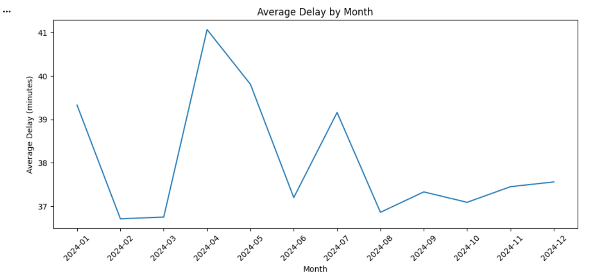

4.2 On-time vs Late Shipments (Bar Chart)
This bar chart compares the number of on-time shipments with late shipments. The chart clearly shows that late shipments are much higher than on-time shipments, meaning delays are a major issue across the network. This is important because it directly impacts customer satisfaction, cost (overtime, penalties), and company reputation. Operational recommendation: managers should treat delay reduction as a high priority and focus on the biggest delay sources first (hubs/routes) using the other charts and summary tables.
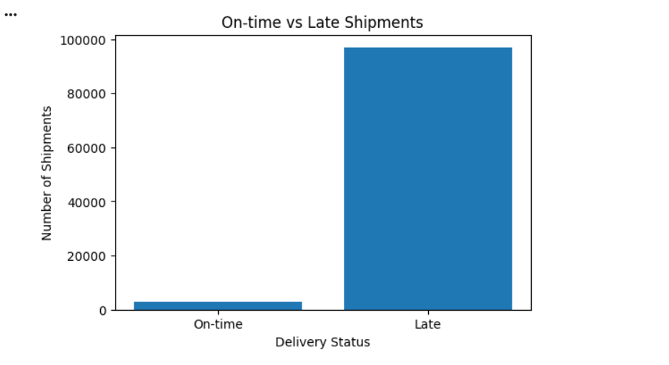

4.3 Average Delay by Day of Week (Bar Chart)
This bar chart shows the average delay for each day of the week. The differences are not extremely large, but the chart shows that some days (for example Tuesday in your results) have slightly higher average delay compared to other days. This suggests that some weekly demand patterns or operational processes may create more congestion on specific days. Operational recommendation: managers can increase staffing or adjust scheduling on the worst day(s), and they can check if certain routes or hubs create weekly spikes.
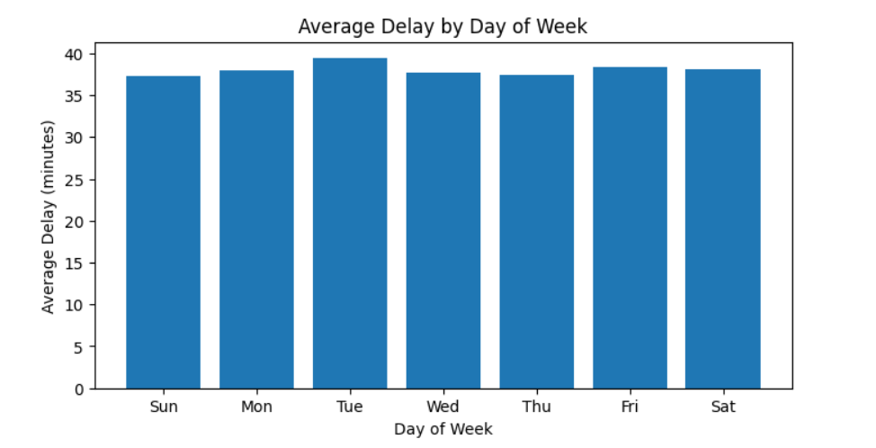

4.4 Average Delay by Departure Hour (Heatmap)
The heatmap shows the average delay across the 24 hours of the day. It highlights that delays are higher during peak operating hours, especially in the morning and late afternoon periods (where the heatmap colors are stronger). This matches real logistics behaviour because trucks, hubs, and roads are busier at these times. Operational recommendation: TransLogix can reduce delays by shifting some departures to off-peak hours, adding staff during peak shifts, and improving hub throughput during busy periods.
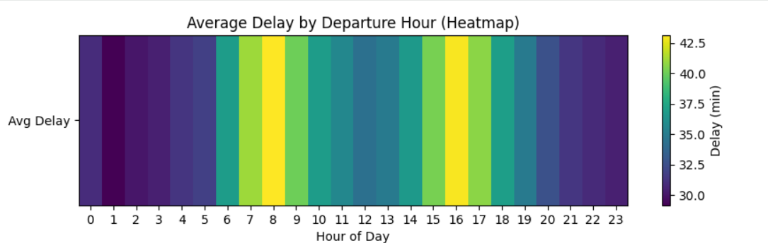

4.5 Origin Congestion vs Delay (Scatter Plot)
This scatter plot shows the relationship between the origin congestion index and delay minutes. The points show that as congestion increases, delays often increase too, but the pattern is not perfect (there is still spread). This means congestion is an important factor, but it is not the only cause of delay (other causes could be route issues, waiting times, or loading speed). Operational recommendation: managers should use congestion index as an early warning signal and focus on congestion control strategies (better scheduling, load balancing, avoiding peak hours, or using alternative hubs when congestion becomes high).
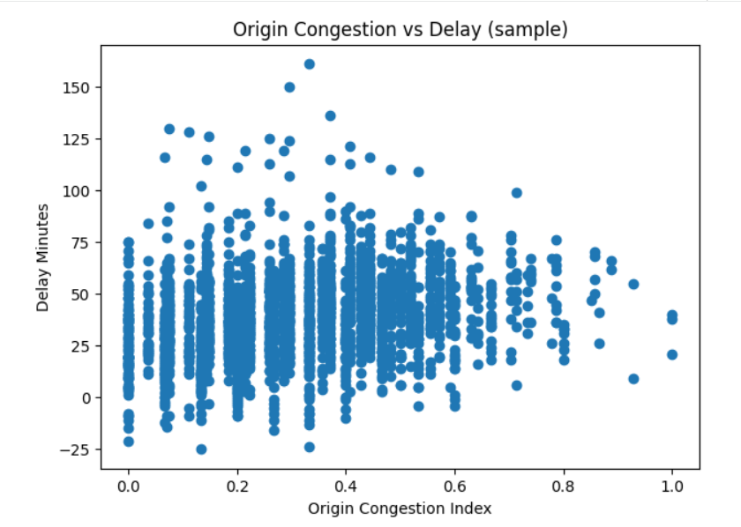

4.6 Top Origin Hubs by Average Delay (Bar Chart)
This chart compares the average delay across origin hubs. It clearly shows that Dubai Central Hub and Jeddah Distribution Hub have higher average delays than Riyadh Logistics Hub. This means the delay problem is not equal across the network—some hubs are much worse. Operational recommendation: managers should prioritize improvement actions at the highest-delay hubs first, such as adding staff, increasing loading capacity, improving scanning workflow, or redesigning the hub process to reduce waiting time.
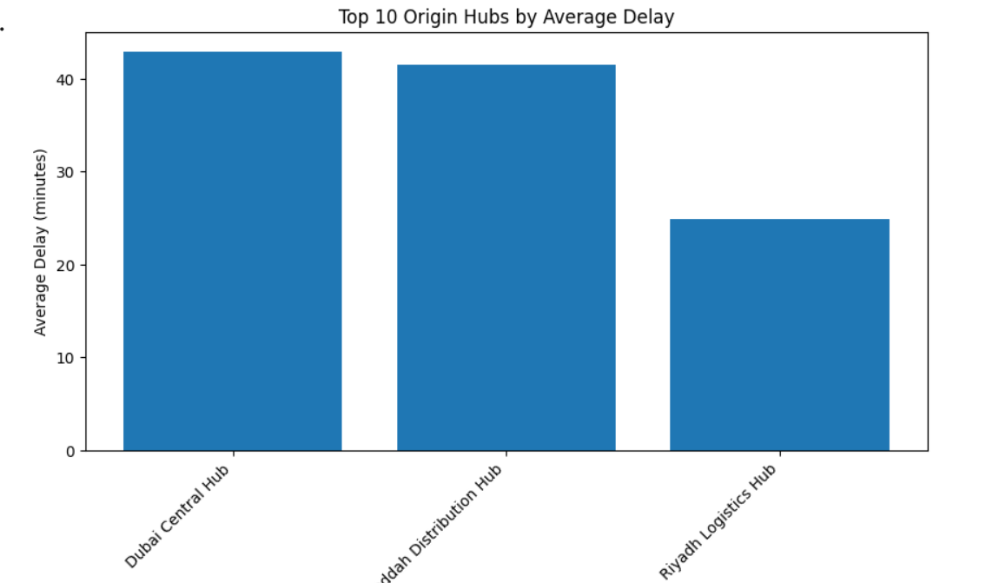
Overall, the visualizations show that delays are affected by time (month/hour/day), hub performance, and congestion level. Managers can use these patterns to focus resources on the worst hubs, plan better staffing during peak periods, and use congestion metrics plus predictive alerts to reduce delays before they happen.

5. Predictive modelling: 3 models to estimate delay_minutes (RMSE + R² comparison)

5.1 Models developed
I built three predictive regression models using Spark ML to estimate delay_minutes:
- Linear Regression
- Random Forest Regressor
- Gradient-Boosted Trees (GBT) Regressor

5.2 Features used (feature selection)
For prediction, I selected operational numeric features:
- origin_congestion_idx, dest_congestion_idx
- distance_km
- time features: dep_hour, dep_dayofweek, dep_month
- derived feature: is_peak_hour
These features were chosen because they represent congestion, distance, and time patterns that affect delays. I excluded IDs and text fields (shipment_id, hub names, route names) because they do not directly represent operational conditions and would require extra encoding.

5.3 Model evaluation results
I split the data into training and testing sets and evaluated each model using:
- RMSE (lower is better)
- R² (higher is better)
Results:
- Linear Regression: RMSE = 19.948, R² = 0.092
- Random Forest: RMSE = 18.465, R² = 0.222
- Gradient-Boosted Trees: RMSE = 18.399, R² = 0.228

5.4 Preferred model and justification
The Gradient-Boosted Trees model is the preferred model because it has the lowest RMSE (18.399) and the highest R² (0.228) among the three models. This means it predicts delays more accurately than the other models. GBT is also suitable for logistics because it can handle non-linear relationships, such as how congestion and peak hours together increase delays. This makes it useful operationally for predicting risky shipments and warning managers early.
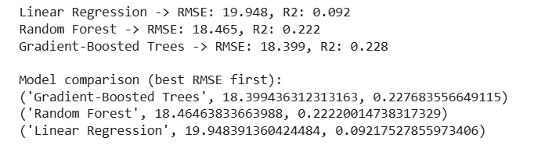

6. Recommendations and decision-making impact + evaluation (with limitations)

6.1 Operational recommendations
Based on the analysis and visual patterns, TransLogix management should consider:
- Focus improvement on the highest-delay hubs by adding staff, improving loading processes, and reducing waiting time.
- Adjust schedules during peak hours if delays are higher in those time windows.
- Monitor high-delay shipments (>60 minutes) and investigate root causes (hub workflow, route issues, congestion).
- Use congestion vs delay insight to justify congestion management, route changes, or hub load balancing.
- Use the predictive model (GBT) to flag shipments likely to be delayed so planners can take preventive actions (rerouting, rescheduling, extra resources).

6.2 Evaluation of effectiveness (tools + methods)
The cleaning and preparation steps improved data quality, so KPIs and charts are more accurate. PySpark was effective for grouping and aggregating large datasets, and it supports scalability for future data growth. Python visualizations were useful for fast exploration and checking patterns, while Power BI was effective for creating a clear dashboard for managers.

6.3 Limitations, assumptions, and improvements
There are limitations and assumptions in this work. The models can only learn from the features available in the dataset, so factors like accidents, weather, vehicle breakdowns, and driver behaviour may not be included. The peak-hour definition is also an assumption and could be improved by using historical evidence to find the real busiest times. The model R² values are not very high, which means delay is influenced by additional factors not captured in the dataset. Future improvements include adding external traffic/weather data, adding more operational variables (hub staffing level, warehouse throughput), and testing more feature engineering or model tuning to improve predictive accuracy.

6.4 Code screenshots
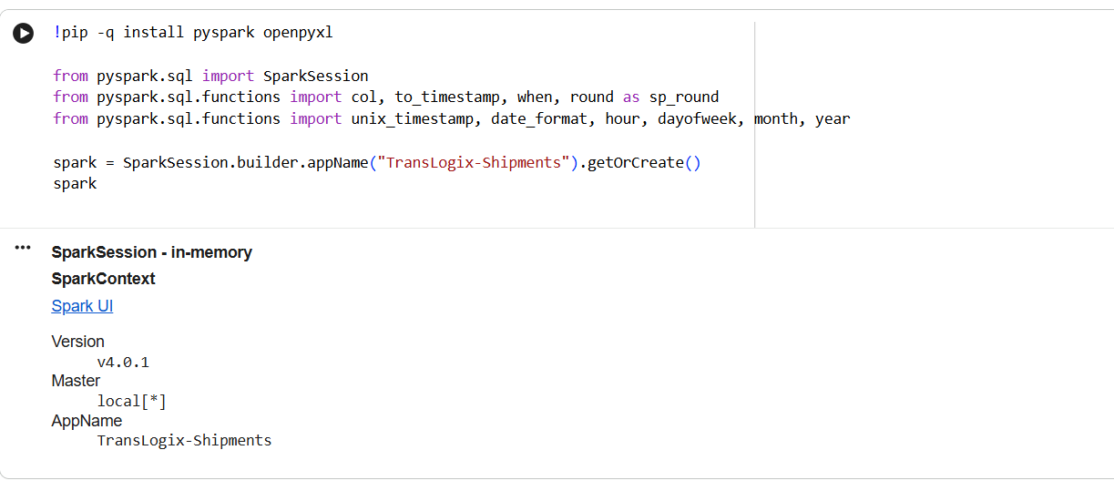
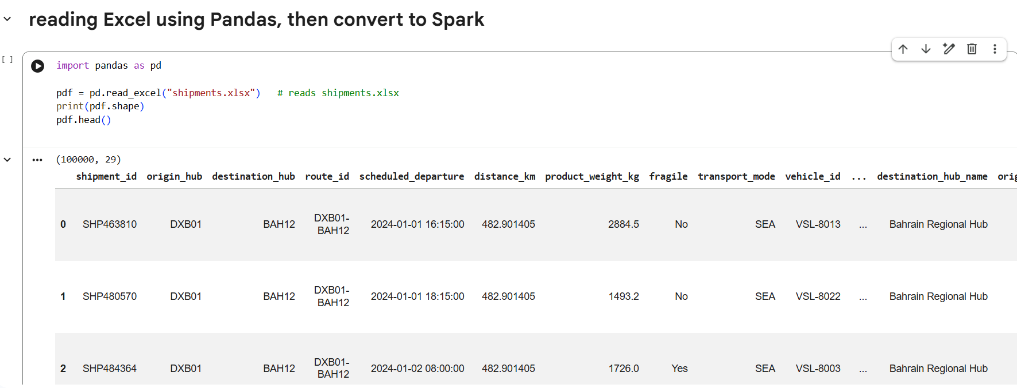

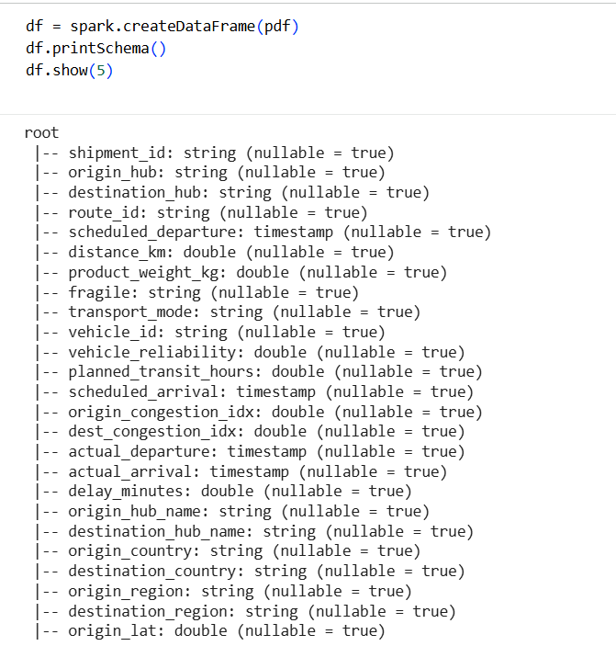
These screenshots show the start of the practical work pipeline where the TransLogix dataset is successfully loaded and prepared for big-data processing using Spark. First, I installed the required libraries and created a SparkSession in Google Colab, which confirms Spark is running and ready to process large datasets. Then, I read the Excel file using Pandas and checked the first rows to confirm the dataset loaded correctly and the columns look correct. After that, I converted the Pandas dataframe into a Spark DataFrame and used printSchema() to verify the data types (for example, timestamps for scheduled/actual times and double types for delay and congestion fields). Finally, df.show(5) confirms Spark can display the records, meaning the dataset is now ready for cleaning, feature engineering, aggregation, visualization, and predictive modelling.
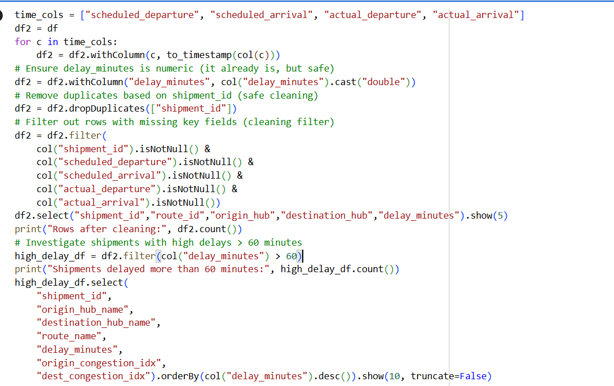
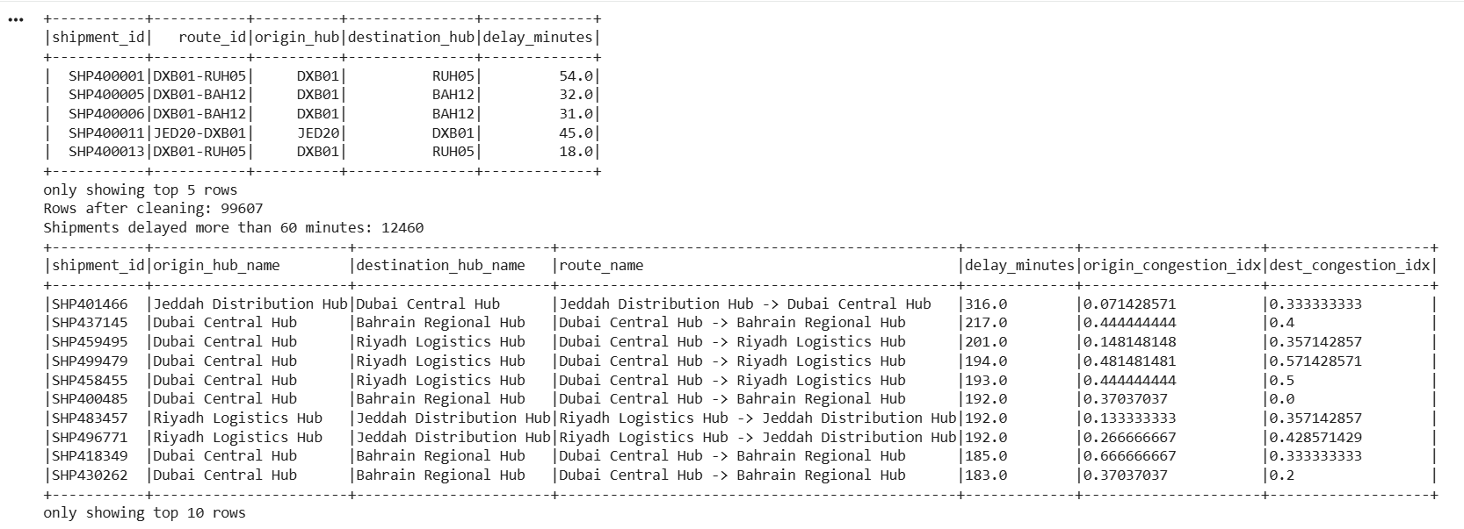
These screenshots show the main cleaning (preprocessing) stage and the first analytical check used in Activity 3. In the code, I first convert the four time columns into correct timestamp format and make sure delay_minutes is stored as a numeric double type so calculations and averages work correctly. Then I remove duplicates using shipment_id to avoid counting the same shipment more than once. After that, I apply a cleaning filter to remove rows with missing key fields (shipment ID and the scheduled/actual departure and arrival times), which improves data quality and makes the analysis more reliable. The output confirms the process worked by showing a sample of cleaned rows and printing the row count after cleaning. Finally, I apply an analytical filter for high-delay shipments (> 60 minutes) and display the top delayed shipments ordered by delay minutes. This helps TransLogix focus on the most severe delay cases and investigate which hubs/routes are causing the biggest operational problems.
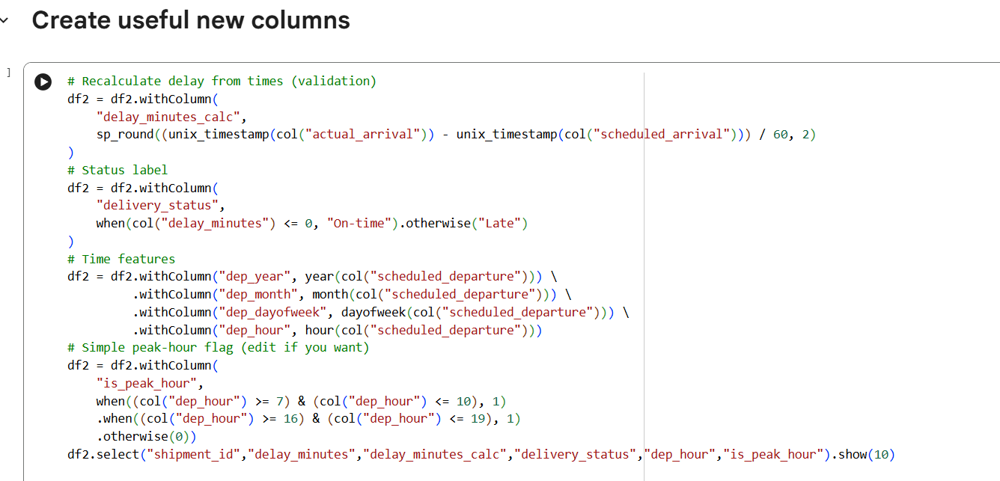
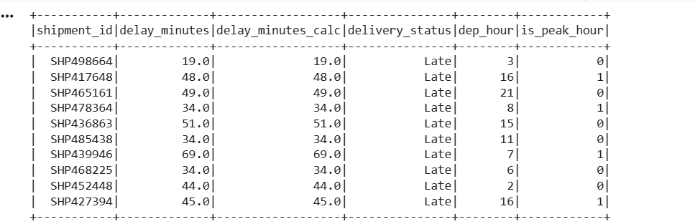
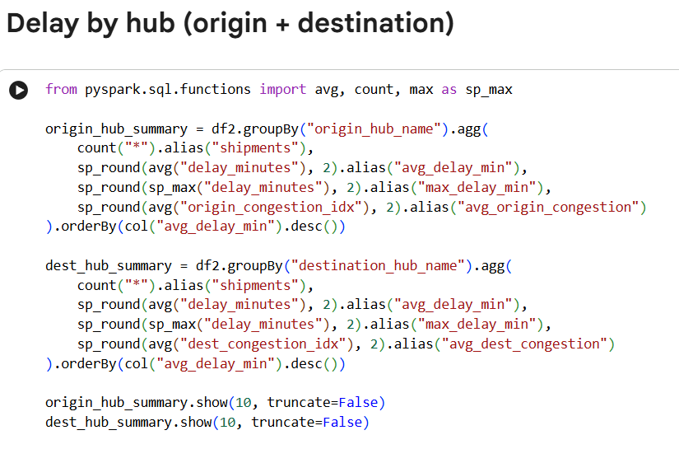
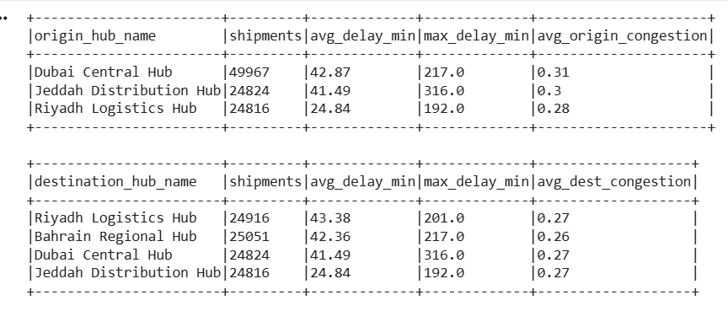
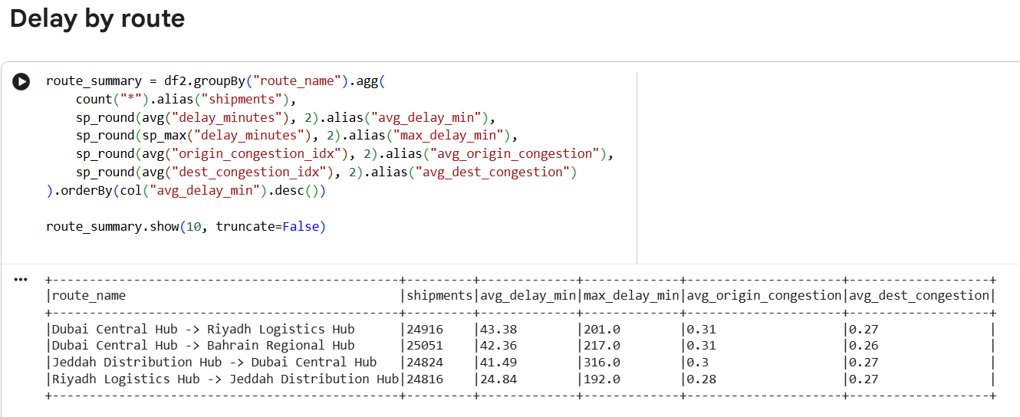
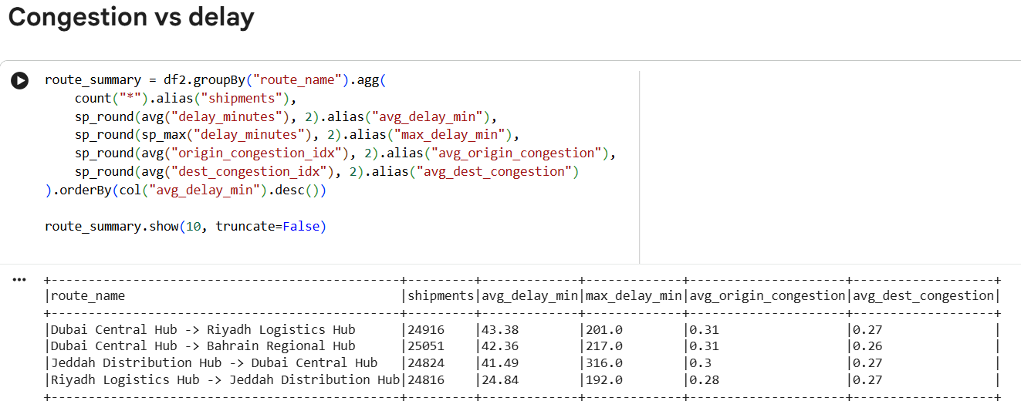
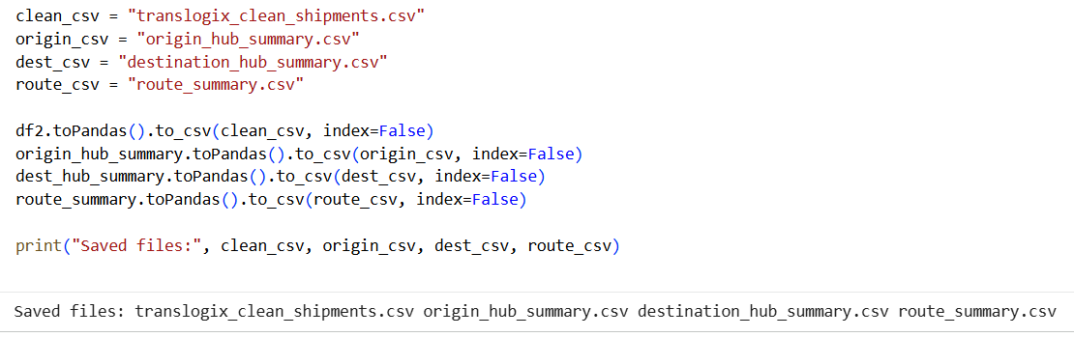
These screenshots show the core analysis stage after cleaning, where the dataset is transformed into decision-ready information for TransLogix managers. First, I create new useful columns (feature engineering) to support analysis: I calculate delay_minutes_calc from the scheduled and actual arrival times to validate delays, I create delivery_status (On-time/Late), and I extract time features such as dep_year, dep_month, dep_dayofweek, and dep_hour. I also add an is_peak_hour flag to identify busy time periods, which helps explain why delays increase during certain hours. After creating these features, I use grouping and aggregation to summarize performance: I calculate shipment count, average delay, maximum delay, and average congestion by origin hub and destination hub. This directly supports operational decision-making by showing which hubs have the worst delays and congestion and should be prioritized for improvements. I also group by route_name to identify route inefficiencies, where some routes have consistently higher average and maximum delays than others. Finally, I export the cleaned dataset and the summary tables (clean shipments, origin hub summary, destination hub summary, route summary) into CSV files. This step supports dashboard building in Power BI because managers can refresh visuals easily using these prepared files instead of working with raw data each time.
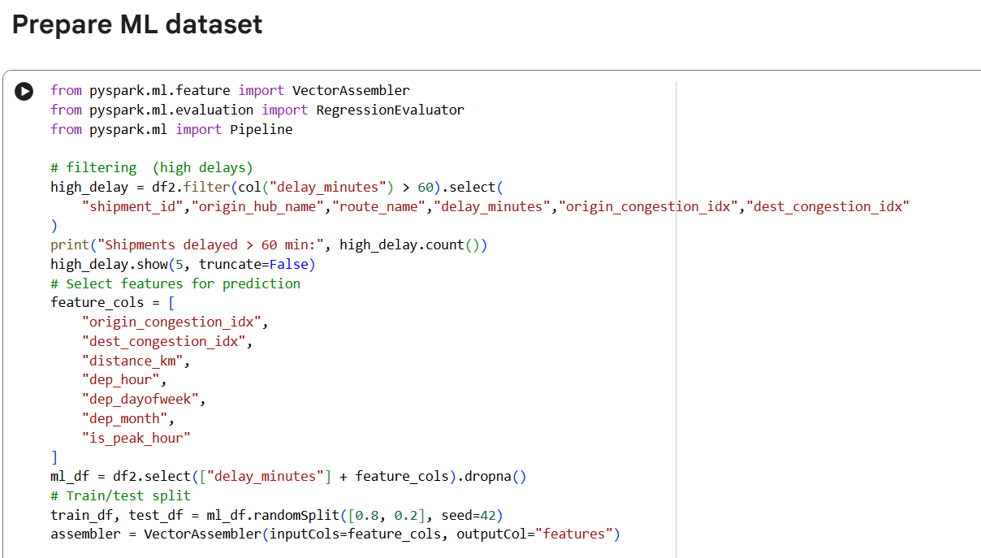
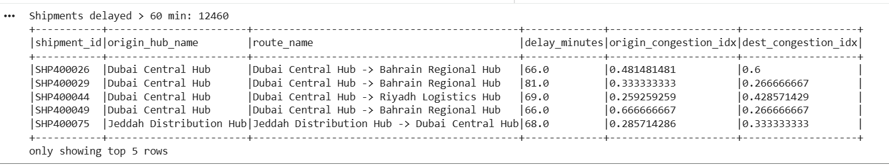
These screenshots show how I prepared the dataset for machine learning (predicting delay_minutes) using Spark ML. First, I apply an analytical filter to identify high-delay shipments (> 60 minutes) and display a small sample of them to understand severe delay cases and the related hubs/routes. Then I perform feature selection by choosing only the operational numeric features that can explain delays, such as origin_congestion_idx, dest_congestion_idx, distance_km, and time-based features (dep_hour, dep_dayofweek, dep_month) plus the derived is_peak_hour flag. After selecting these features, I create the ML dataframe by keeping only delay_minutes and the selected feature columns, and I remove missing values using dropna() to avoid errors during training. Finally, I split the data into training and testing sets (80/20) and use VectorAssembler to combine the selected columns into a single features vector. This makes the dataset ready to train and compare the three predictive models in the next step.
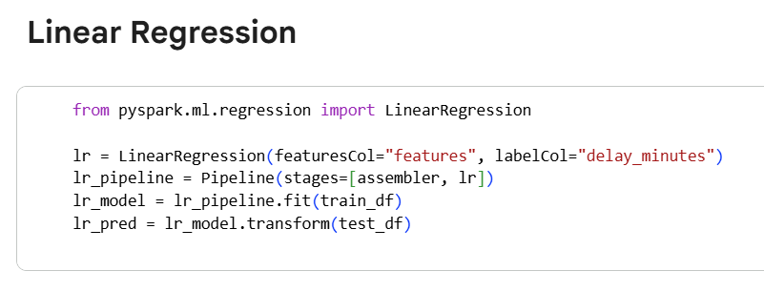
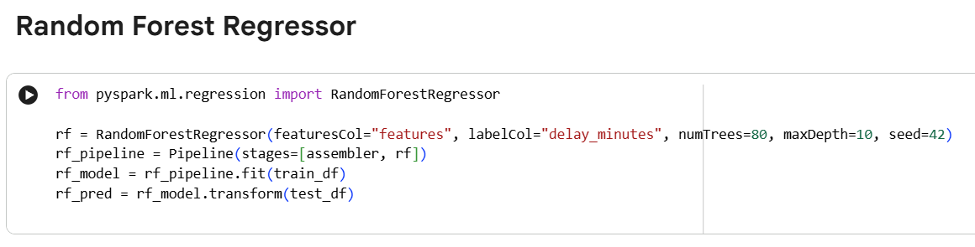
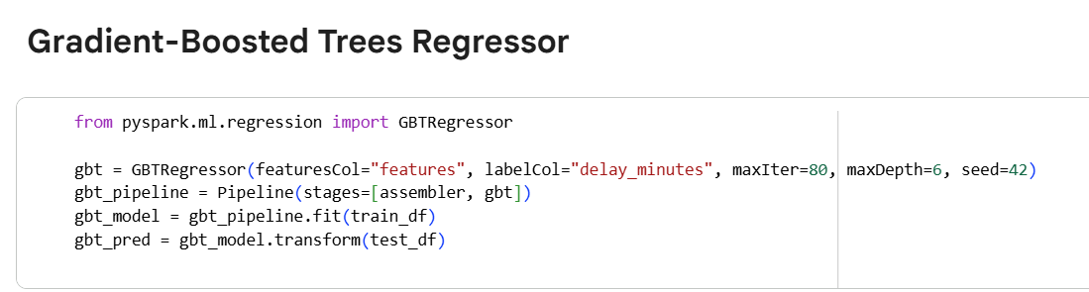
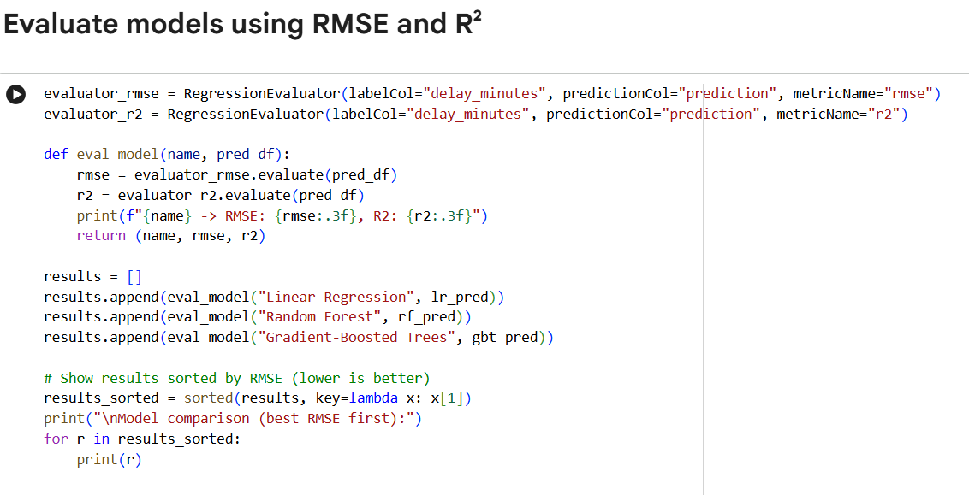
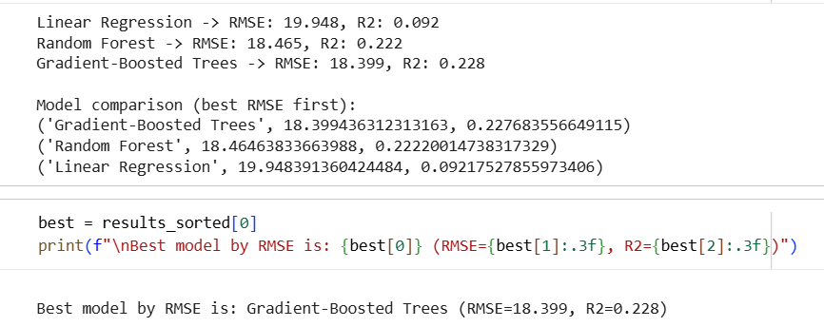
These screenshots show the predictive modelling part, where I built and compared three regression models to estimate delay_minutes using Spark ML. First, I trained a Linear Regression model as a simple baseline, then a Random Forest Regressor to capture more complex (non-linear) relationships, and finally a Gradient-Boosted Trees (GBT) Regressor to improve accuracy by combining many small decision trees. Each model was trained using the same pipeline structure (VectorAssembler + model) and then used to predict delays on the test dataset. After training, I evaluated all models using two required metrics: RMSE (lower is better) and R² (higher is better). The results show that Linear Regression performed the worst (RMSE ≈ 19.95, R² ≈ 0.09), while Random Forest improved accuracy (RMSE ≈ 18.47, R² ≈ 0.22). The best model was Gradient-Boosted Trees, with the lowest RMSE (≈ 18.40) and the highest R² (≈ 0.23), so it is the most suitable choice for TransLogix because it predicts delays more accurately and can better handle complex delay factors like congestion and peak hours.

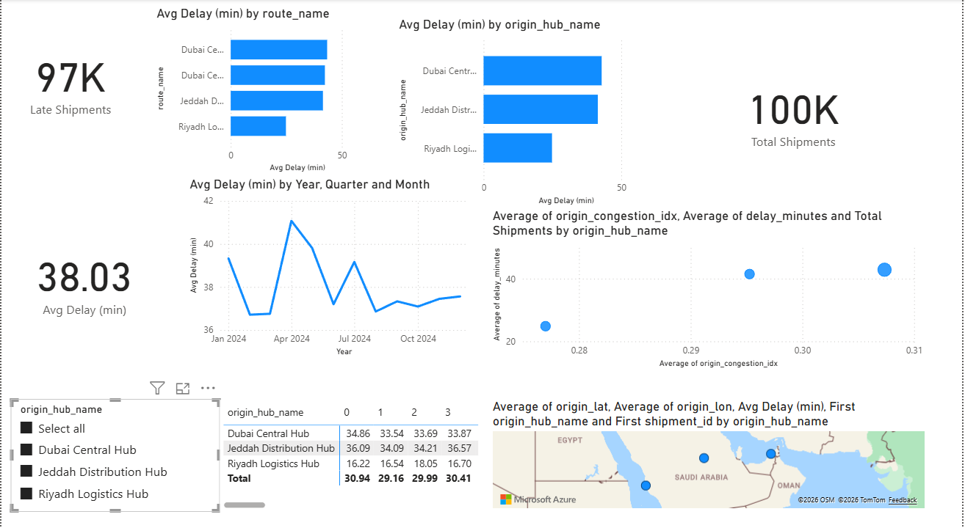

This screenshot shows the final Power BI dashboard built from the cleaned TransLogix data and the summary tables created in Python/PySpark. The dashboard focuses on shipment delay performance and hub congestion, and it is designed for managers to make quick operational decisions. At the top, I added KPI cards for Total Shipments (100K), Late Shipments (97K), and Average Delay (38.03 min) so decision-makers can instantly understand overall performance. Then I included bar charts for Avg Delay by route_name and Avg Delay by origin_hub_name to highlight which routes and hubs are causing the biggest delays, which supports actions like improving workflows or adding resources in the worst locations. I also added a time trend line chart (Avg Delay by Year/Quarter/Month) to show how delays change over time and help managers identify peak periods. To analyse the link between congestion and delay, I used a scatter chart comparing average origin_congestion_idx vs average delay_minutes, with bubble size based on shipment volume, so hubs with high congestion and high delay are easy to spot. I added a hub slicer (origin_hub_name) so users can filter the whole dashboard and compare hubs interactively, and I included a table/matrix showing hub metrics for quick detailed review. Finally, I added a map visual using hub latitude/longitude to show hub locations, which supports location-based understanding of where congestion and delays are happening. Overall, this dashboard turns the prepared data into clear visuals and KPIs that help TransLogix managers decide where to focus (worst hubs/routes), when to act (time trends), and why delays happen (congestion relationship).

Activity 4 Professional Roles and Challenges in Big Data Environments

1. Introduction
TransLogix is a logistics and supply-chain company that uses big data from GPS, telematics, warehouse scanners, and fleet systems. Because the data is large and fast, TransLogix needs different data professionals to manage it, analyze it, and use it safely. This report explains the main roles and day-to-day responsibilities of data specialists, the key issues they face, the strategies used to ensure legal and ethical compliance, and how these issues affect people working in a data-driven culture.

2. Roles, day-to-day responsibilities, and key issues

2.1 Data Engineer
A Data Engineer builds and maintains the data pipelines that move data from trucks and hubs into storage systems. At TransLogix, this includes collecting GPS data, hub scan data, and shipment records, then cleaning, validating, and storing it in a usable format. Their daily work involves building ETL processes, fixing pipeline failures, managing data quality checks, and making sure data arrives on time for dashboards and models. A key issue for data engineers is dealing with data variety (many formats) and velocity (real-time streams). Another issue is that if pipelines fail or data is late, managers may make decisions using old or incomplete data.

2.2 Data Analyst / Business Intelligence (BI) Analyst
A Data Analyst (or BI Analyst) focuses on reporting and dashboards. At TransLogix, this role creates Power BI dashboards to show average delay, late shipments, and top delayed hubs/routes. The analyst also supports managers by answering questions like “Which hub is worst this week?” and “Is performance improving?” Their day-to-day work includes preparing datasets for reports, creating measures (KPIs), building visuals, and explaining results to non-technical users. Key issues include misinterpretation of charts, wrong KPI definitions (e.g., on-time % calculated incorrectly), and data refresh problems. If the dashboard is not designed well, managers may make wrong decisions.

2.3 Data Scientist / Machine Learning Engineer
A Data Scientist builds predictive models and advanced analytics. At TransLogix, this includes predicting delay minutes, detecting risky routes, and creating models that support proactive decisions (like rerouting). Their daily work includes feature engineering, model training, evaluation (RMSE, R²), and monitoring model performance over time. Key issues include bias, low-quality data (veracity), and model explainability. If the model is inaccurate or not trusted, managers may ignore it. Also, delays can be affected by factors not in the dataset (accidents, weather), which limits model performance.

2.4 Data Governance / Compliance Officer
A data governance specialist ensures the company uses data legally and ethically and follows company rules. At TransLogix, this includes ensuring correct handling of driver data, customer shipment data, and GPS tracking records. Their daily work includes setting policies (who can access data), ensuring security controls, ensuring retention rules, and checking compliance. Key issues include privacy risks, misuse of sensitive data, weak access control, and unclear ownership of datasets.

2.5 DevOps / Cloud Engineer (Big Data Platform Support)
This role supports the infrastructure such as cloud storage, Spark clusters, and deployment systems. At TransLogix, they manage performance, scaling, and reliability of the analytics platform. Daily work includes monitoring system health, controlling costs, ensuring uptime, and supporting deployments. Key issues include cost control, security patches, and keeping systems stable when data volume increases.

3. Strategies to ensure compliance (legal, ethical, data governance)

3.1 Data privacy and confidentiality
TransLogix must protect sensitive information such as driver location data and customer shipment information. A main strategy is data minimization, meaning only collecting and using the data needed for business goals. Another strategy is anonymization/pseudonymization where possible, such as using driver IDs instead of names in analytics datasets. This reduces privacy risk while still allowing analysis.

3.2 Access control and role-based permissions
A strong strategy is role-based access control (RBAC). This means only authorized staff can access certain datasets. For example, BI analysts may access aggregated delay data, but only a small security team may access detailed driver tracking data. This reduces risk of leakage and misuse.

3.3 Data quality governance (rules + monitoring)
Data governance includes quality rules such as removing duplicates, handling missing values, and validating timestamps. This should be supported by automated checks in pipelines and regular audits. These strategies help ensure dashboards and models are based on correct data, which improves decision quality.

3.4 Ethical use of analytics and avoiding bias
TransLogix should use guidelines that prevent unfair decisions. For example, if data from one hub is incomplete, the system should not automatically blame that hub. A strategy is to use fairness checks, review results with domain experts, and explain model outcomes clearly so decisions are not based on misunderstanding.

3.5 Retention, documentation, and audit trails
TransLogix should set policies about how long data is kept and document data sources, transformations, and definitions (data dictionary). Audit trails (logs) help track who accessed data and when, which supports accountability.

Assessment of how well strategies work + improvement needs
These strategies are effective only if they are applied consistently. In practice, problems happen when departments store data differently, when access rules are not updated, or when staff do not follow procedures. TransLogix should improve by running regular compliance checks, training staff on data ethics, and using automated monitoring for security and data-quality problems.

4. Evaluation of impact of key issues in a data-driven culture

4.1 Impact of data quality and standardization issues
If data quality is poor (missing scans, wrong timestamps), then analytics results become unreliable. This affects data specialists because they spend more time cleaning data instead of doing advanced analysis, and it creates stress when managers demand quick answers. For the company culture, poor data quality reduces trust in dashboards and models. Strength: cleaning rules and validation can fix many problems. Weakness: if each hub records data differently, standardization becomes difficult. Best response: create standard data-entry rules and strong automated validation in the pipeline.

4.2 Impact of security and privacy risks
GPS and driver data is sensitive. If privacy controls are weak, TransLogix may face legal and reputational risks. This increases pressure on compliance staff and data engineers to secure systems. Strength: RBAC and encryption reduce risk. Weakness: systems can still be misused if training is poor. Alternative action: stronger monitoring, audits, and privacy-by-design (build privacy into systems from the start). The issue is significant because data-driven culture depends on trust and responsibility.

4.3 Impact of bias and unfair decision-making
If analytics or models unfairly target a hub or driver group because of incomplete data, it can harm staff morale and cause wrong operational decisions. In a data-driven culture, this can create fear that “data is used to blame people” instead of improving processes. Strength: bias checks and human review reduce unfair outcomes. Weakness: bias can be hidden and hard to detect. Alternative action: add fairness review steps before acting on model outputs, and use transparent KPIs. This issue is important because it impacts both performance and employee trust.

4.4 Impact of complexity and skills gap
Big data tools (Spark, pipelines, ML models) require strong technical skills. If there is a skills gap, TransLogix may rely on a few experts, which is risky. Strength: training and documentation can improve capability. Weakness: hiring and upskilling takes time. Alternative action: use managed tools, simplify dashboards, and create standard reusable pipelines. This issue is significant because without the right skills, the organization cannot fully benefit from a data-driven strategy.

Reasoned judgement (overall importance for TransLogix)
The biggest issues for TransLogix are data quality, privacy/security, and bias risk, because they directly affect trust in analytics and the ability to make correct decisions. If these issues are not managed, a data-driven culture can become harmful (wrong decisions, unfair blame, low trust). If TransLogix invests in strong governance, standardization, and training, the company can build a healthy data-driven culture where data specialists support real improvements in delays and congestion.

5. Conclusion
TransLogix needs several data professional roles (data engineers, analysts, data scientists, compliance officers, and platform engineers) to manage big data and support decisions. These professionals face issues like data quality, privacy risk, bias, and technical complexity. Compliance strategies such as RBAC, data quality rules, ethical guidelines, documentation, and audits help reduce risk and improve trust. Overall, managing these challenges is critical for TransLogix to succeed in a data-driven culture and to improve logistics performance safely and fairly.

References
- Apache Spark Documentation (Overview)
https://spark.apache.org/docs/latest/
- PySpark (Apache Spark Python API Docs)
https://spark.apache.org/docs/latest/api/python/index.html
- Apache Spark (Project Home Page – What is Spark?)
https://spark.apache.org/
- Apache Hadoop (Project Home Page – HDFS, YARN, MapReduce modules)
https://hadoop.apache.org/
- Apache Hadoop YARN Documentation (Official)
https://hadoop.apache.org/docs/stable/hadoop-yarn/hadoop-yarn-site/YARN.html
- Apache Hadoop Documentation (Stable Release Docs)
https://hadoop.apache.org/docs/r3.4.2/
- YARN Research Paper (Free PDF): “Apache Hadoop YARN: Yet Another Resource Negotiator”
https://www.cse.ust.hk/~weiwa/teaching/Fall15-COMP6611B/reading_list/YARN.pdf
- Microsoft Learn: KPI visual in Power BI (Official)
https://learn.microsoft.com/en-us/power-bi/visuals/power-bi-visualization-kpi
- CRISP-DM “No Brand” PDF (Classic process model document)
https://keithmccormick.com/wp-content/uploads/CRISP-DM%20No%20Brand.pdf
- CRISP-DM Original Paper (Wirth & Hipp, Free PDF)
https://cs.unibo.it/~danilo.montesi/CBD/Beatriz/10.1.1.198.5133.pdf
- IBM SPSS Modeler CRISP-DM Guide (Free PDF)
https://www.ibm.com/docs/it/SS3RA7_18.3.0/pdf/ModelerCRISPDM.pdf
- “The CRISP-DM Model: The New Blueprint for Data Mining” (Shearer, Free PDF)
https://mineracaodedados.files.wordpress.com/2012/04/the-crisp-dm-model-the-new-blueprint-for-data-mining-shearer-colin.pdf
- Databricks: Apache Spark overview (Industry platform docs, free web page)
https://docs.databricks.com/aws/en/spark/
- Power BI KPI tutorial (free guide – not official but accessible)
https://www.datacamp.com/tutorial/power-bi-kpi
- Apache Spark Documentation Index (all guides list)
https://spark.apache.org/documentation.html

